APPLICATION  for  SCCT MEMBERSHIP  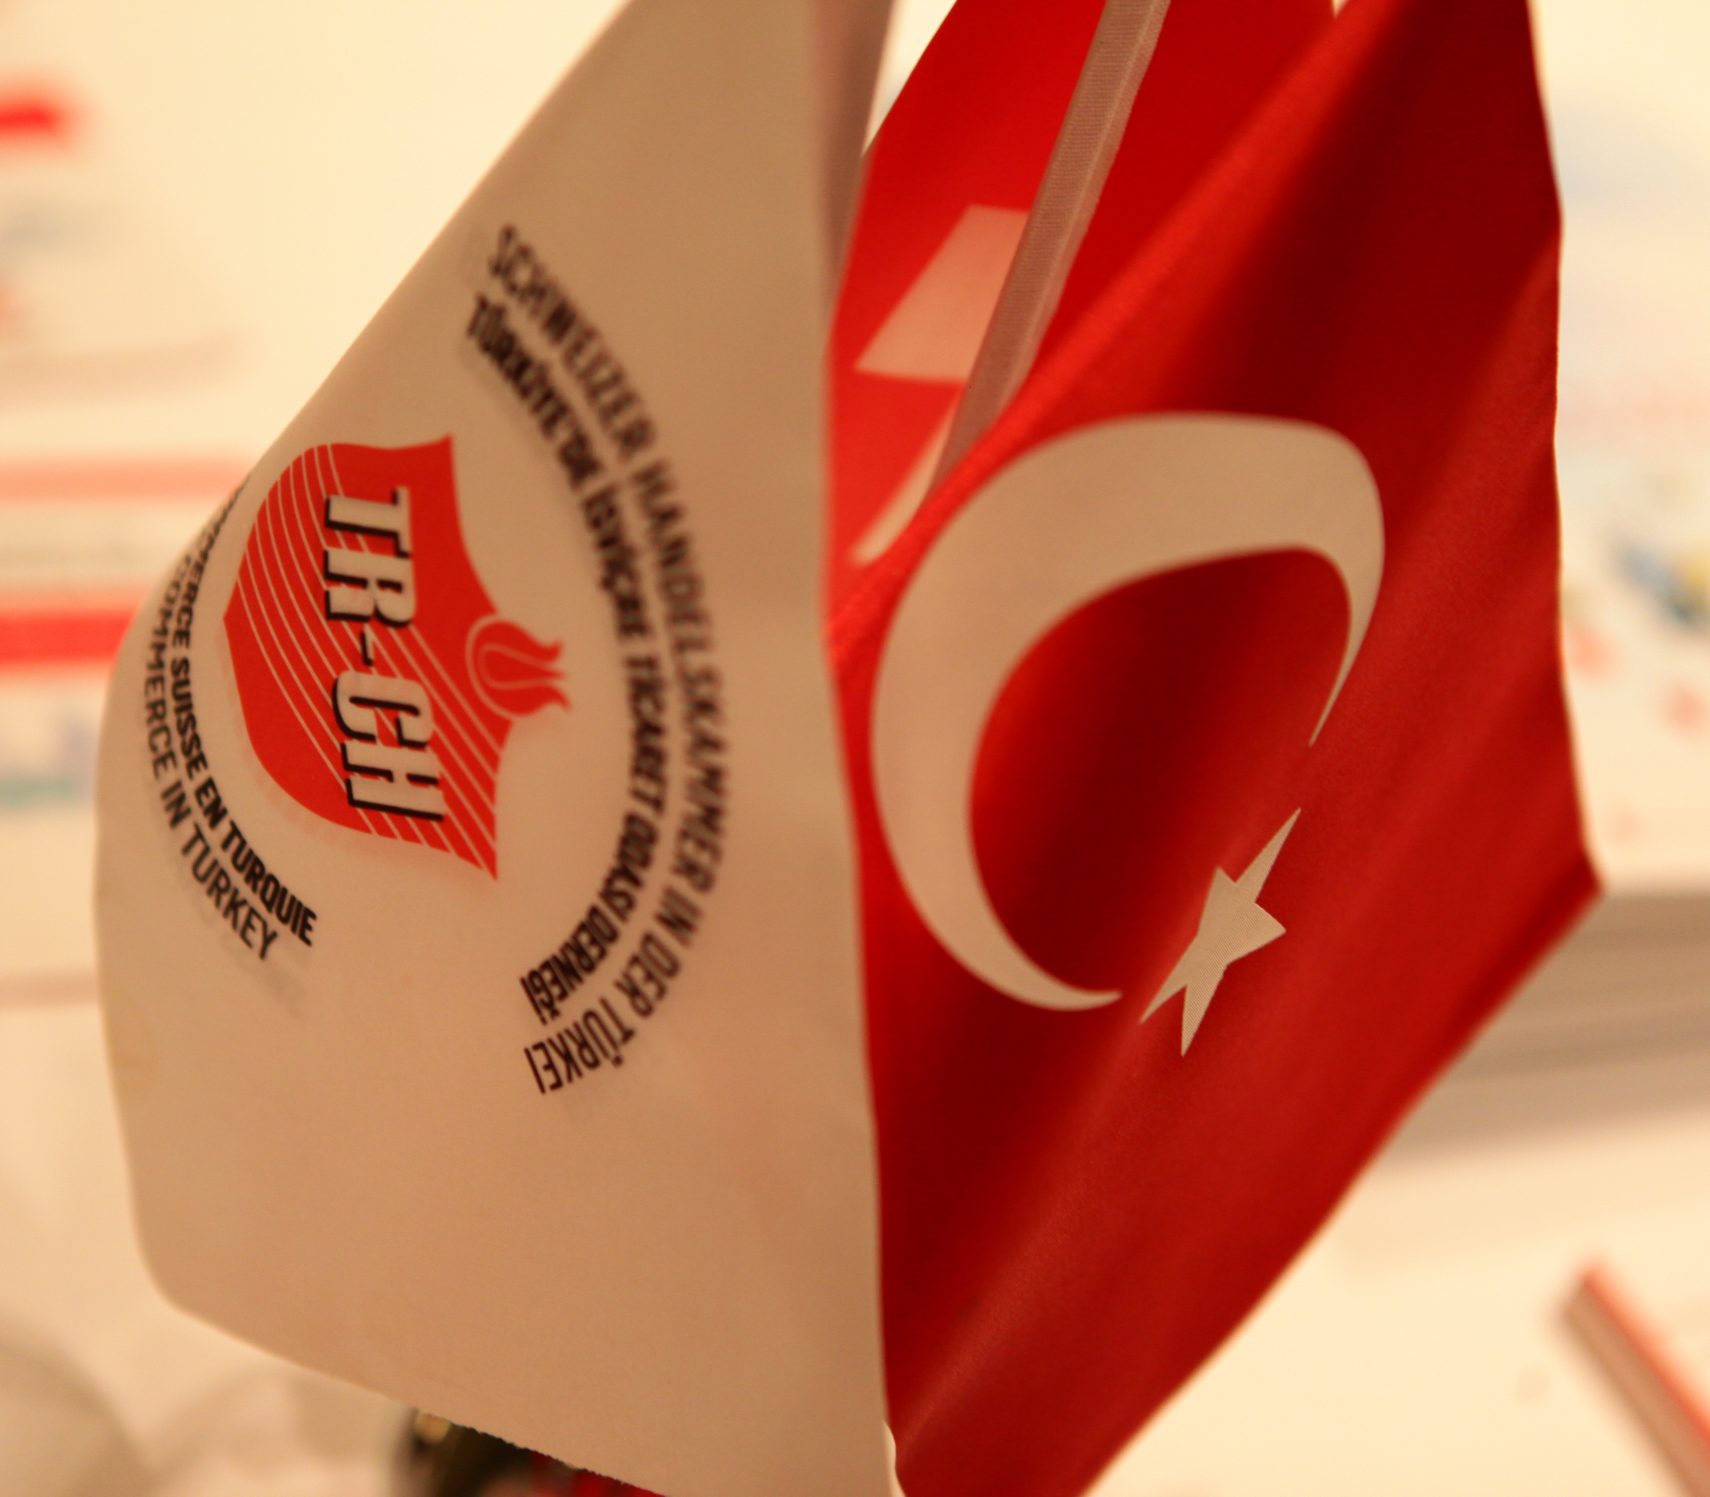 | Adres | Address  Mecidiyeköy Mah., Ada Residence  Şehit Ahmet Sok. N: 6-10 K:4 D: 62  Mecidiyeköy ISTANBUL  Tel: +90 212 211 14 35  Fax: +90 212 211 14 36  Web: www.tr-ch.org  E-mail: info@tr-ch.org  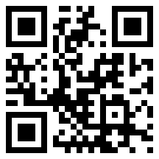  Kütük No | Registration Number  34/033-008  Zincirlikuyu V.D. 8790009654

REFERENCE |  | (If you were introduced by a member of SCCT)
Company Name:
Contact Name:
ABOUT YOUR COMPANY
(Optional for Individual Membership, required for Corporate & Associate Membership applications)
Company Name:
Also known as:
MERSİS (Central Registration System) Number:
Address:
City: |  |  | Country: |  |  |  |  | Postcode:
Phone: |  |  |  |  | Email:
Website:
Tax Office: |  |  |  |  | Tax ID:
Foreign Capital: | ☐ Turkish Company ☐ Swiss Capital Company in Turkey
 | ☐ Swiss Company ☐ Turkish Capital Company in Switzerland
 | ☐ Other:
Type of Entity: | Choose an item.
Main products, services, areas of interest and expertise:
Business Sector(s): (please add more than one if needed)
Choose an item.
Choose an item.
Choose an item.
Choose an item.
☐ Other Business Sector:

MAIN CONTACT
First Name:
Last Name:
Job Title:
(*Home Address only required from Individual Members)
Home Address:
City: |  | Country: |  |  |  | Postcode:
Phone: |  |  | Email:
Mobile:
National ID No. (T.C. Kimlik No.):
Year of Birth:
Nationality: | ☐ Turkish |  | ☐ Other:
Education: | Choose an item.
Profession: | ☐ Choose an item. |  | ☐ Other:
Interests: | (please select the topics this contact would like to receive emails about)
 | ☐ SCCT e-Newsletter |  |  |  | ☐ Member Notifications
 | ☐ Event Announcements
Consent for the processing of personal data
As SCCT, we are committed to protecting your privacy and only collect, use and process information about you in accordance with the legal requirements attached to our organisation being an Association.
I have read the above clarification and am knowledgeable of its content. I hereby freely provide explicit consent to my personal data being collected, used & processed for the purposes of SCCT membership.
Date: |  |  | Signature:

ADDITIONAL CONTACT 1 |  |  |  | (Optional)
First Name:
Last Name:
Job Title:
Phone: |  | Email:
Mobile:
Interests: | (please select the topics this contact would like to receive emails about)
 | ☐ SCCT e-Newsletter |  | ☐ Member Notifications
 | ☐ Event Announcements
Consent for the processing of personal data
As SCCT, we are committed to protecting your privacy and only collect, use and process information about you in accordance with the legal requirements attached to our organisation being an Association.
I have read the above clarification and am knowledgeable of its content. I hereby freely provide explicit consent to my personal data being collected, used & processed for the purposes of SCCT membership.
Date: |  | Signature:

MEMBERSHIP SUBSCRIPTION
New members are charged a one-off registration fee of 400 CHF. This fee is only payable on joining and is not applied to renewals. Membership runs for 12 months from the date of joining and is renewable on the 1st of the month of joining.
Membership Fee
Annual Fee: |  | 600.00 CHF
Registration Fee: |  | 400.00 CHF
Total: |  | 1.000.00 CHF
☐ Include us in the Corporate Member Directory on SCCT’s website (Corporate Members only)
Payment Method:
 | ☐ Online Credit Card Payment via sevda.topcu@tr-ch.org
 | ☐ Direct Bank Transfer

BANK DETAILS
Bank / Branch: |  | Akbank Ortaklar Şubesi (692)
Account Name: |  | Türkiye’de İsviçre Ticaret Odası Derneği
Swift Code: |  | AKBK TR IS
TRY Account No.: |  | 888-0692-0106318 |  | TRY IBAN No.: | TR36 0004 6006 9288 8000 106318
CHF Account No.: |  |  |  | CHF IBAN No.: | TR46 0004 6006 9202 1000 106322
STATEMENT
I/We confirm that the information provided in this application form given is correct, that I/we agree to be bound by the Articles of Association and bylaws of SCCT, and that l/we undertake to inform SCCT immediately if/when any of the information declared on this application form is changed or updated.
Full Name:
Date: |  |  | Signature:

MEMBERSHIP APPLICATION CHECKLIST
Please make sure to send the below documents to complete your membership application, either by mail to our office or by email to sevda.topcu@tr-ch.org

- Corporate or Associate Members
☐ | Completed Application Form
☐ | Trade Activity Certificate (for Turkish Companies (‘Faaliyet Belgesi’))  or Companies Act given at Companies House (for foreign Companies only)
☐ | Signature Circular (Turkish Companies)
☐ | Full Payment of SCCT Membership Fee (400 CHF Entry Fee + 600 CHF yearly)
In case you have opted to be listed in SCCT’s online Corporate Member Directory:
☐ | Company logo (High resolution / vector)
☐ | Company description in English, 2-3 paragraphs  (additional description in Turkish is optional)

- Individual Members
☐ | Completed application form
☐ | A photocopy of your ID card or passport, with ID Number
☐ | 1 photograph
☐ | Full Payment of SCCT Membership Fee (400 CHF Entry Fee + 600 CHF yearly)

